Git account creation and usage

<https://youtu.be/UF8prUYlA98>

NOTE: Install GIT and later follow the below setps, <https://git-scm.com/download/win>

**Note: Number indicates below screen number accordingly**

1, 2, 3,  create and login to Git.

4, create repository

5, create one eclipse Maven project.

6, take the Maven project location.

7, Git command.

8, go to your command prompt Maven project, run command: **git init** (it creates one hidden file, to see run dir hidden file seeing command)

9, paste, earlier copied git command in command prompt and run.(to register with git)

10, **git status**. Show how many pending to check in.

11, **git add .**   To add all the files to Git. After adding, type **git status** to see.

12, **git commit -m**"give your comments" it shows files which are ready to push

13, steps to push into git.

14, **git push origin master** to push the code, it gets permission denaied msg.

15, create ssh key by following step.(this is for windows, similarly Mac steps also available in the same website.)

16, later go to settings, ssh key, create new: give title and ssh key. Click on add.

17, now go back to command prompt and try the command, give your laptop password.

18, now code is available in git repository.

19, add one more class and update one class, follow the check in process.

--------------------------------

20, to pull the code, go to command prompt and create directory where you want to pull the code.

21, to pull code, first time you have to clone. Copy the repository URL.

22, **git clone URL..........**  To pull the code.

23, go eclipse, select file, import, as java/Maven project, based on the project.(for Maven chose Maven project, existing Maven project and import)

24, update some file in git repository and commit.

25, to get latest: **git pull origin master**

26, you can see the update in eclipse.

**…or create a new repository on the command line**

echo "# ActiTimeMavenTestAutomation" >> README.md

git init

git add README.md

git commit -m "first commit"

git remote add origin https://github.com/vishnugit49/ActiTimeMavenTestAutomation.git

git push -u origin master

**…or push an existing repository from the command line**

git remote add origin https://github.com/vishnugit49/ActiTimeMavenTestAutomation.git

git push -u origin master

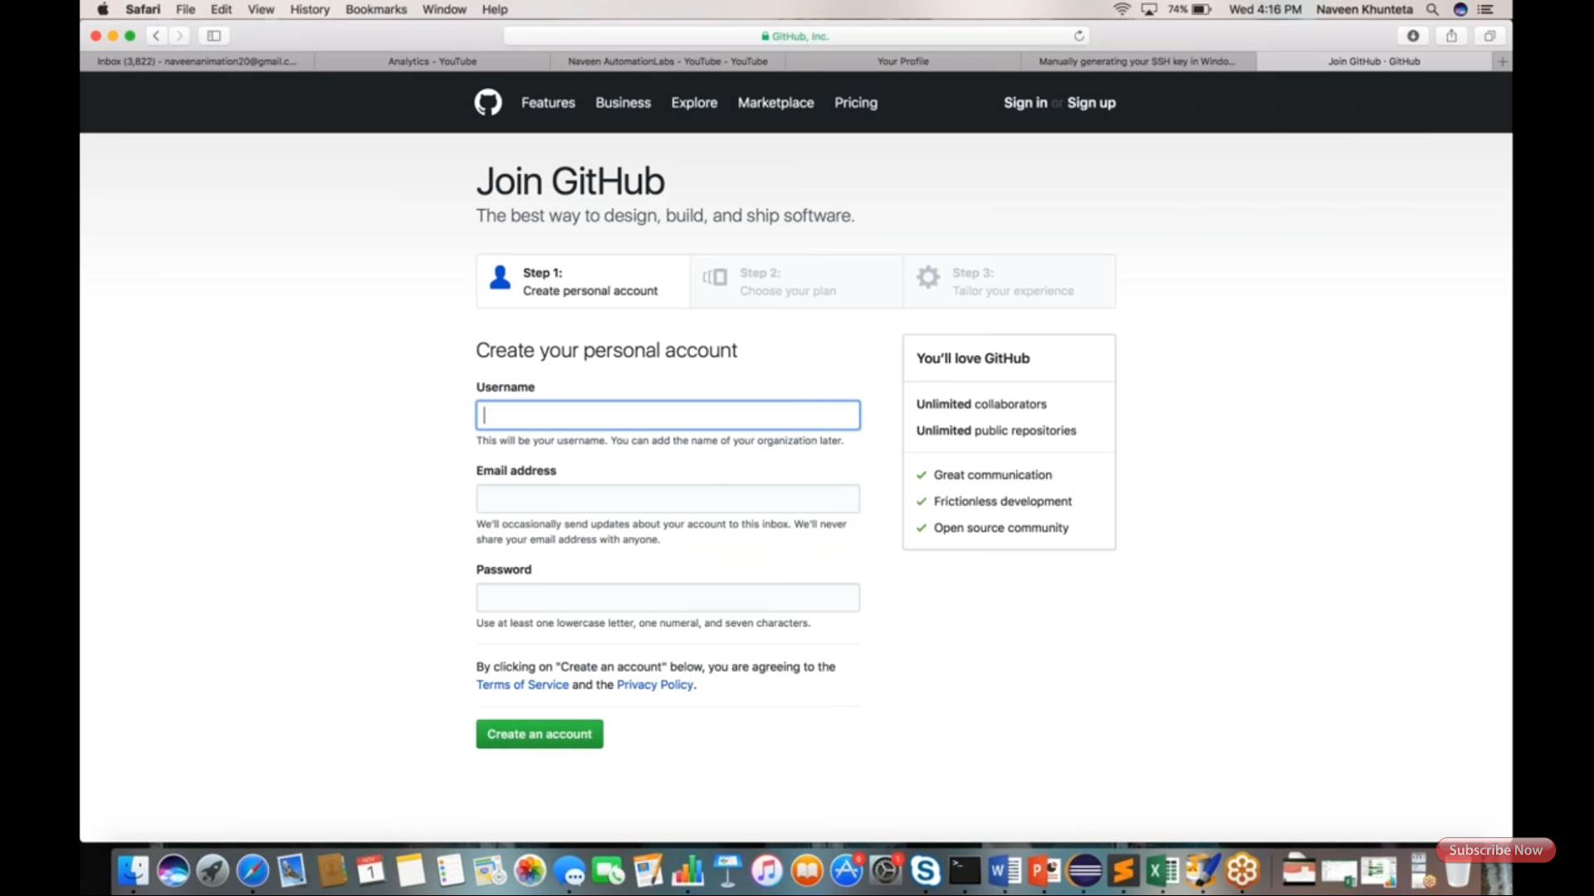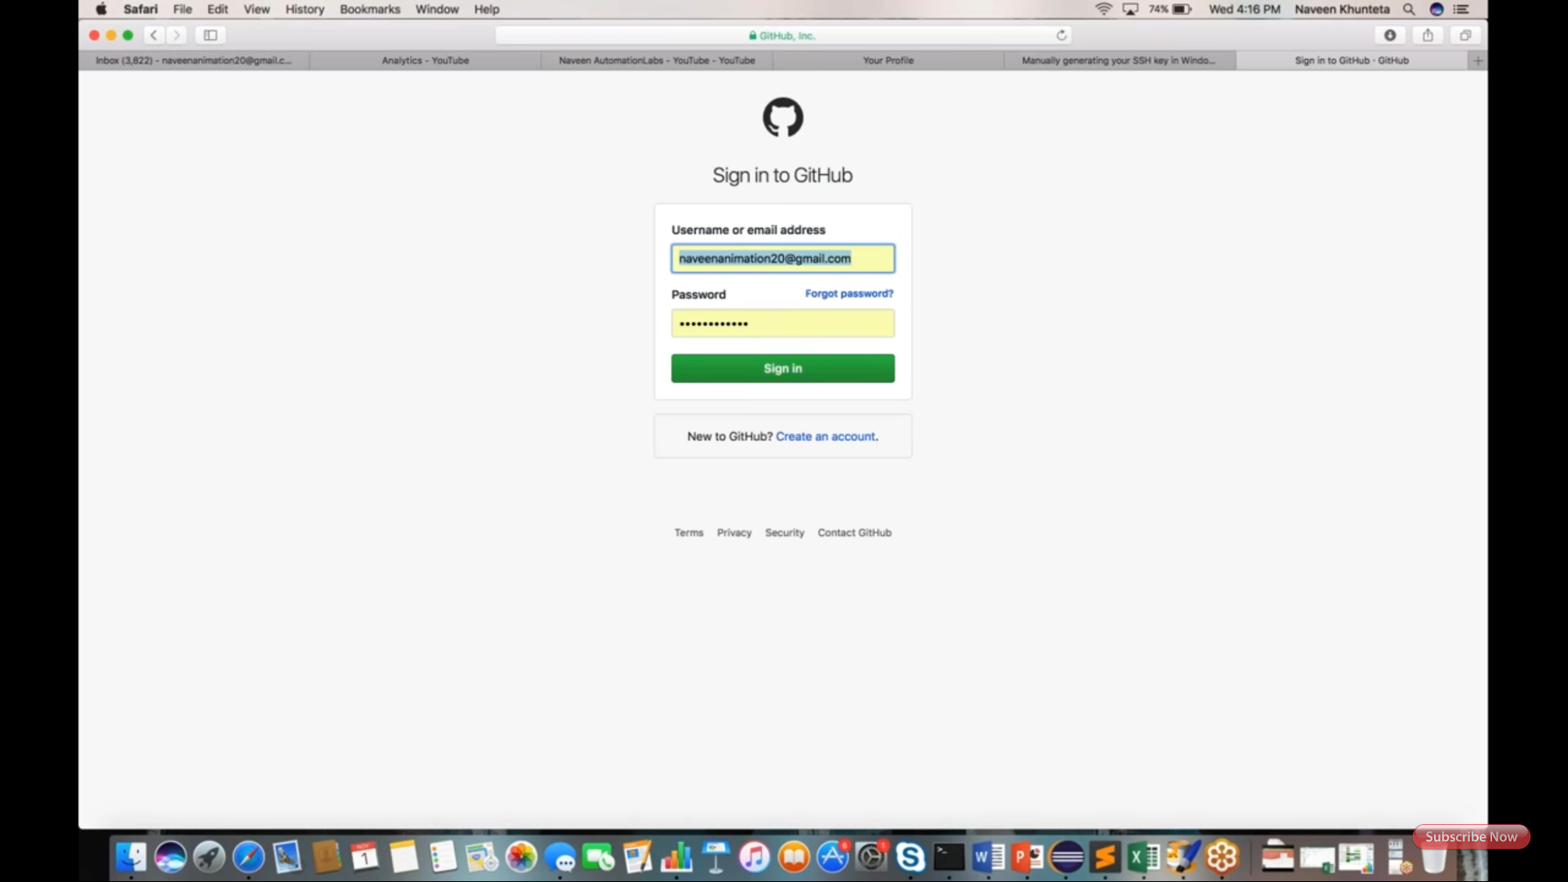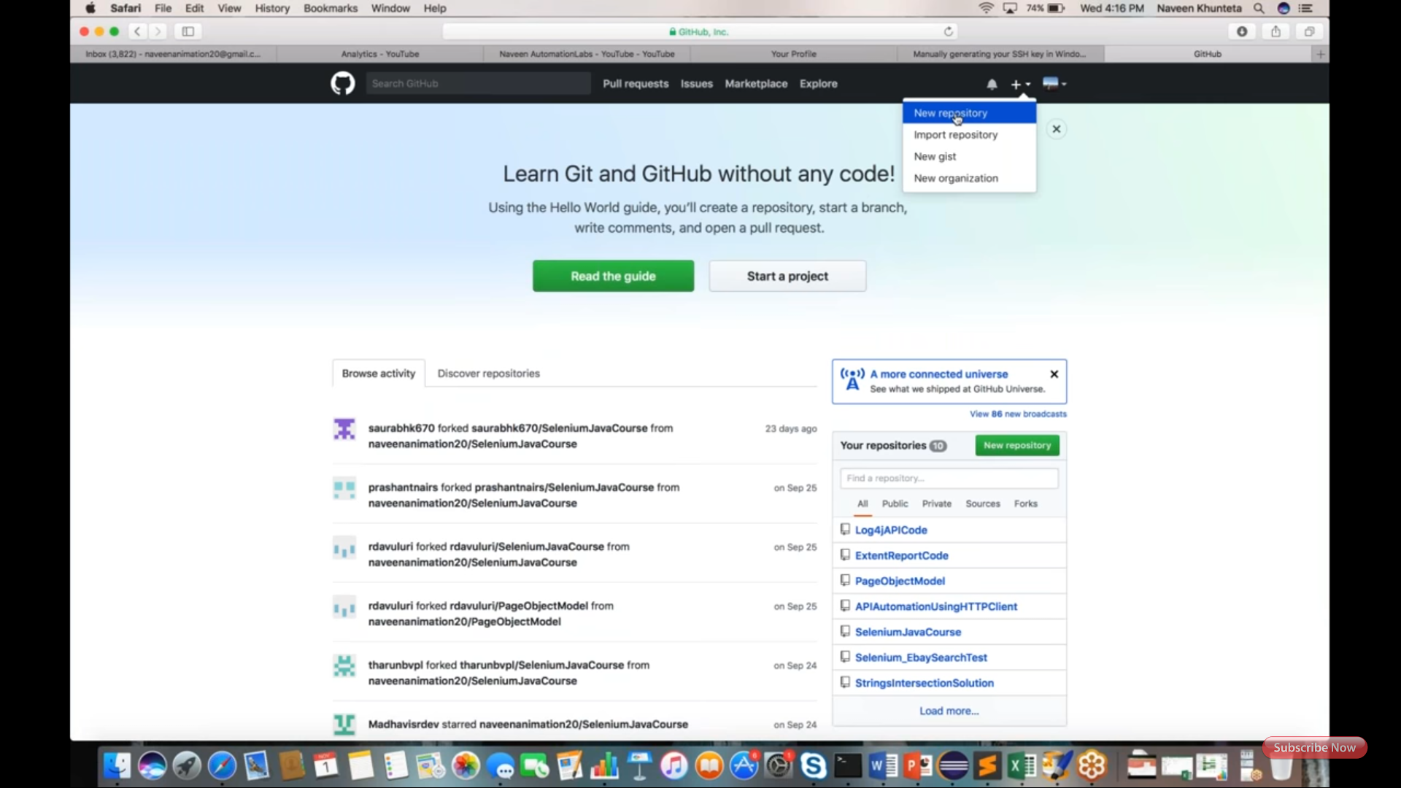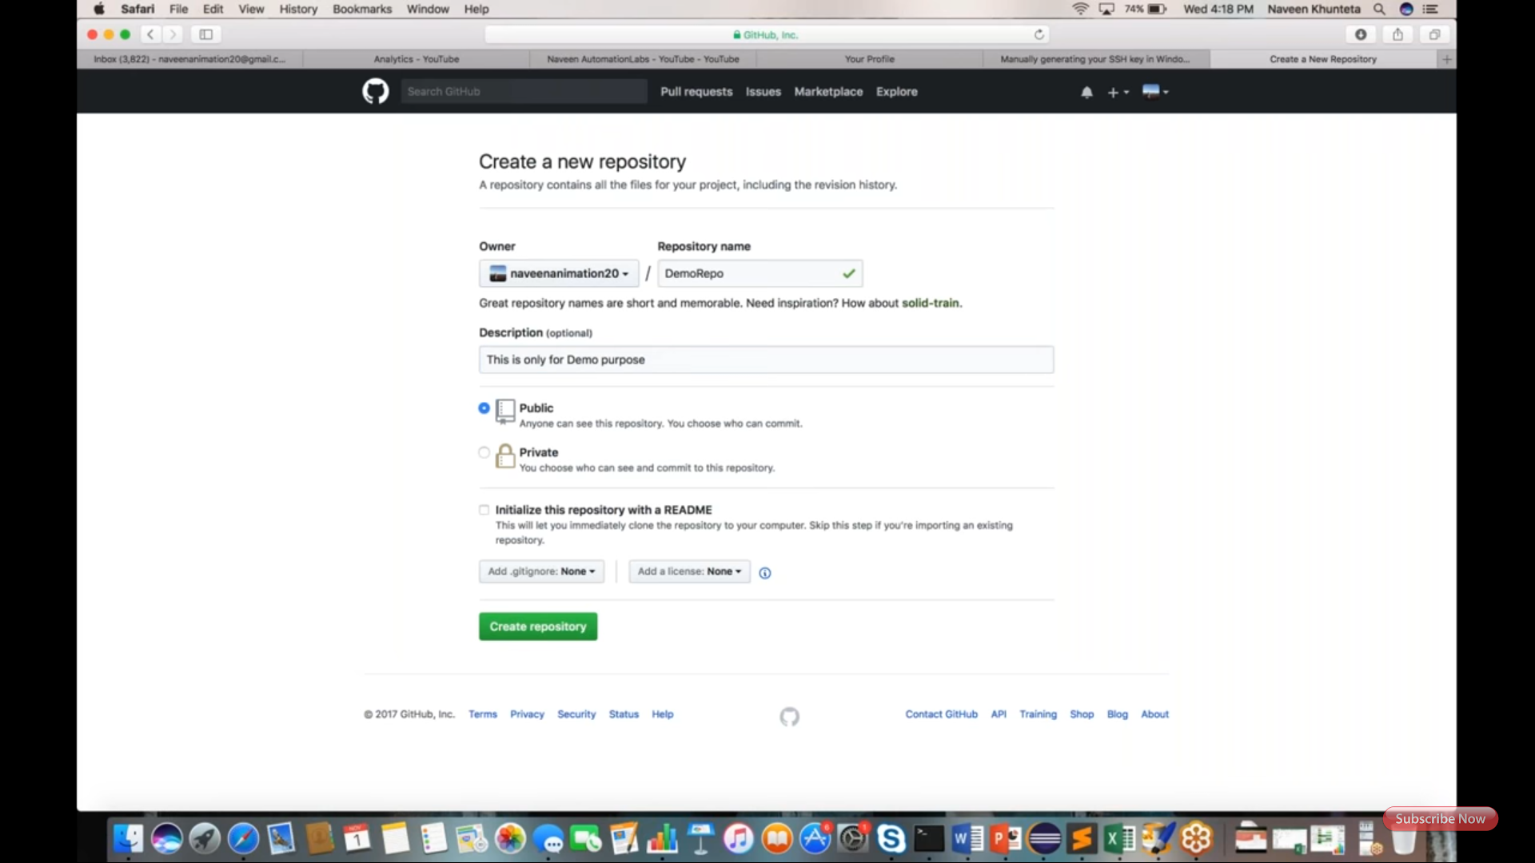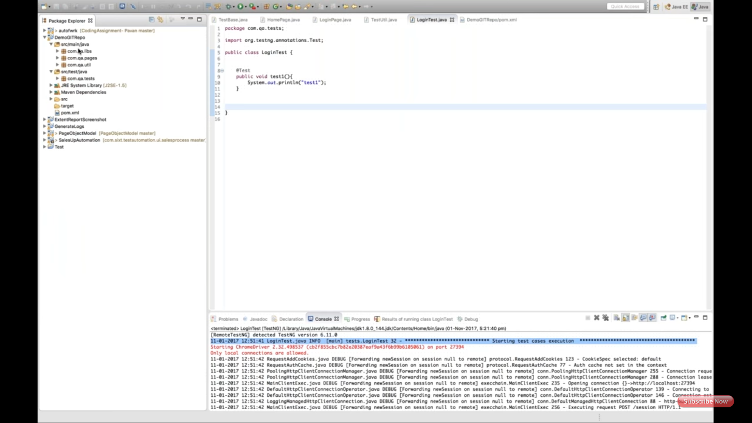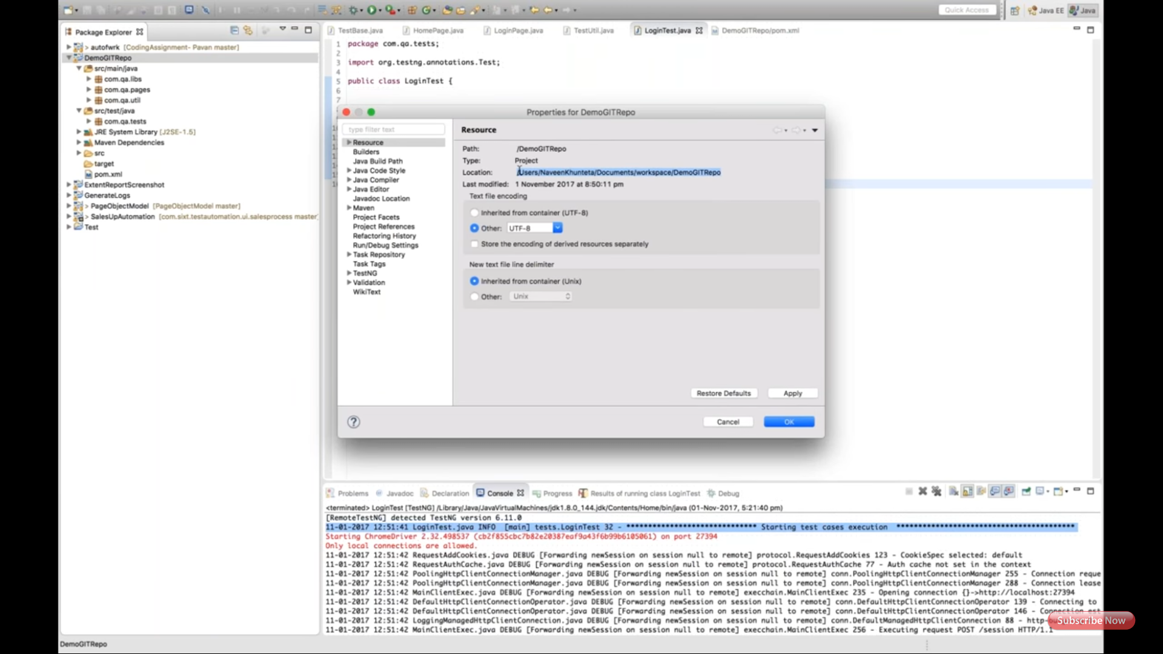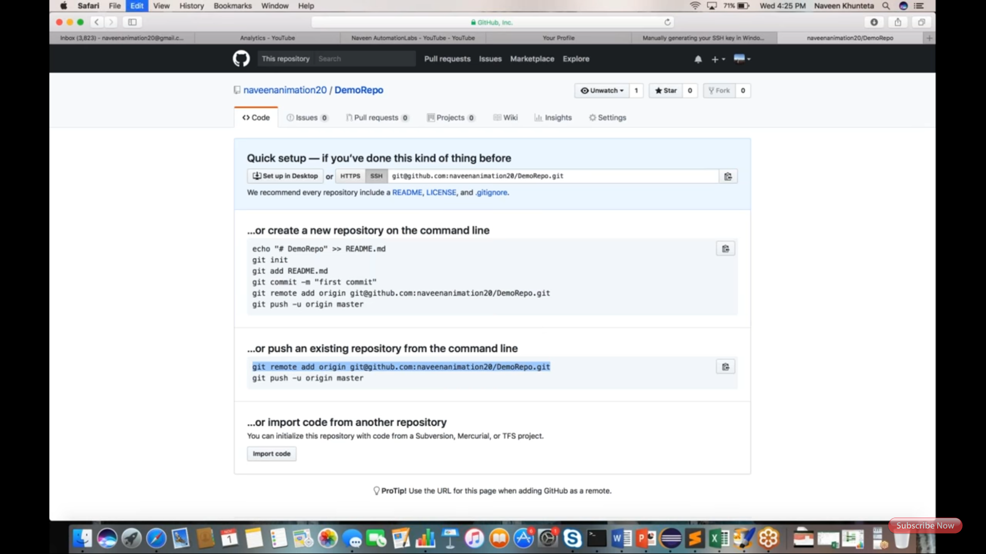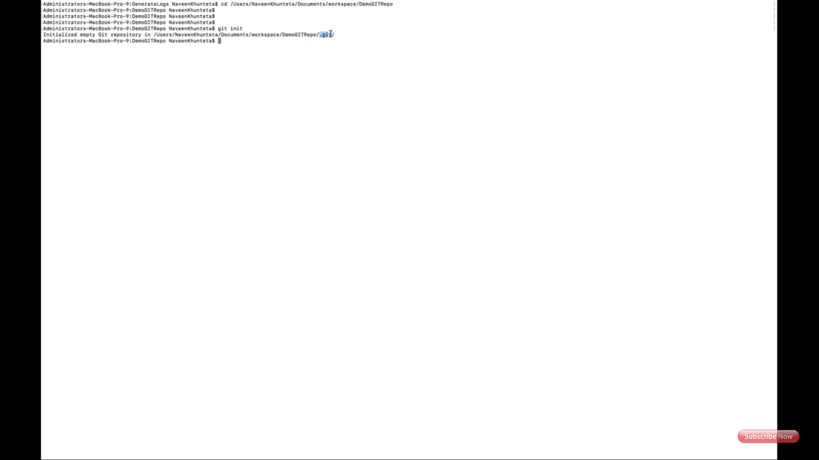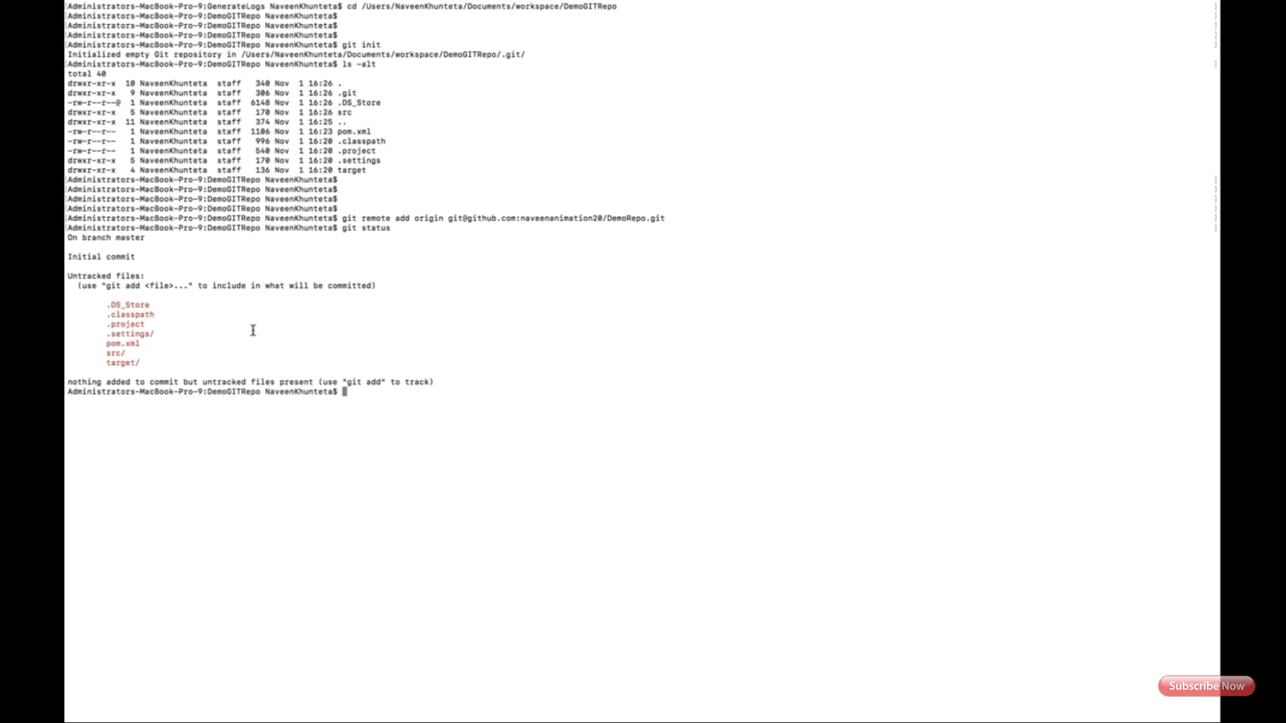

After this use this command: git add . (GIT ADD SPACE and DOT)

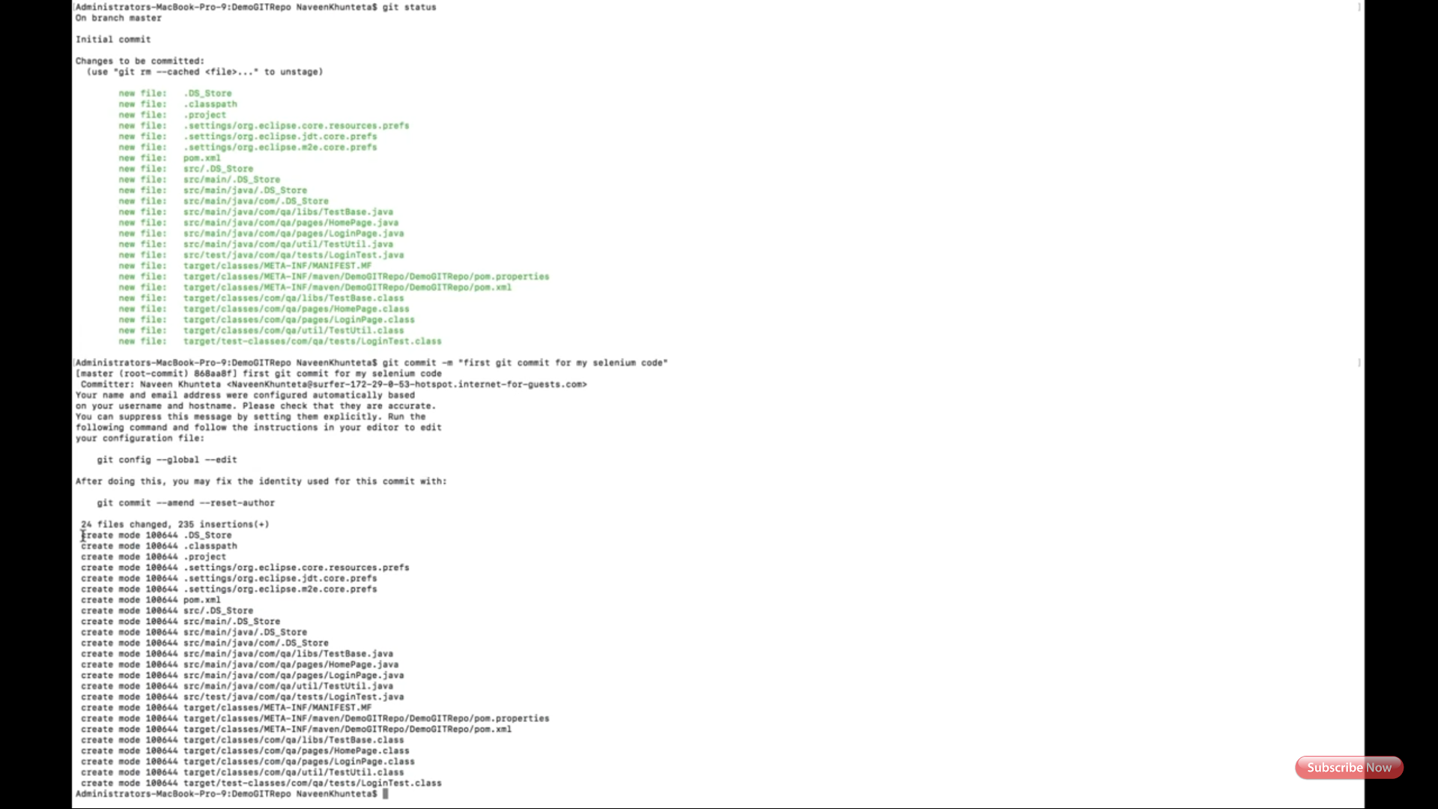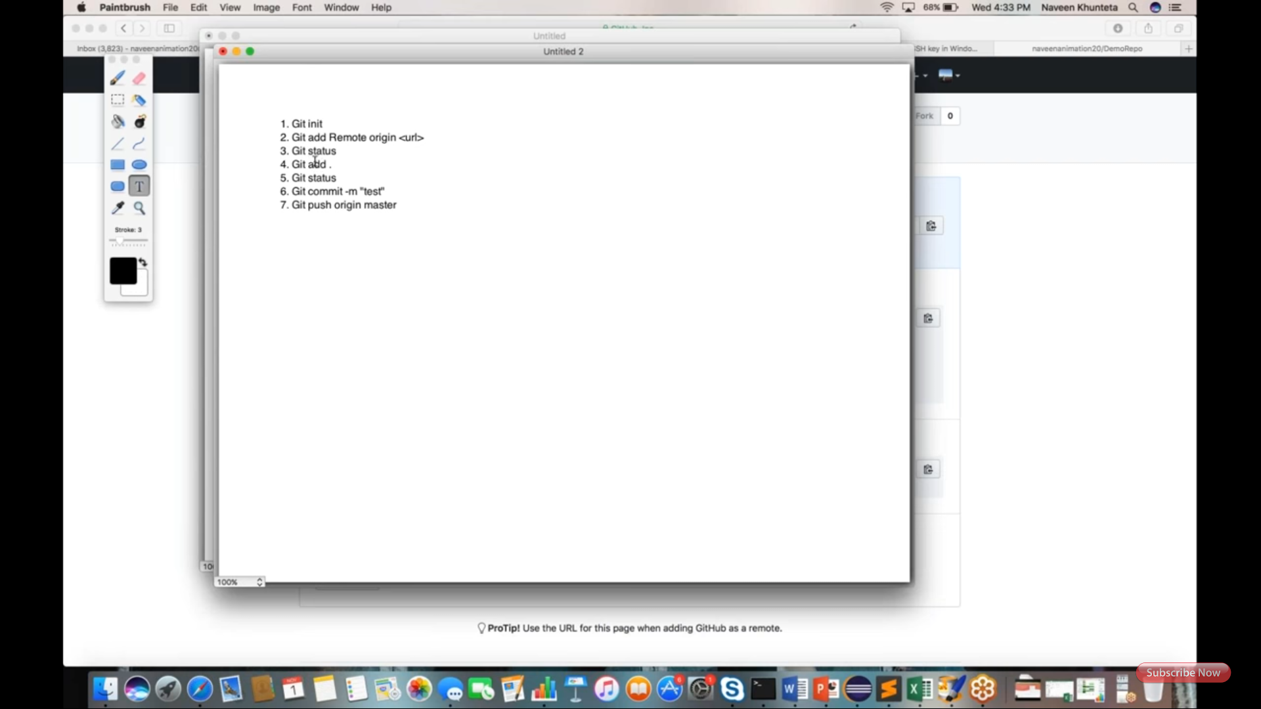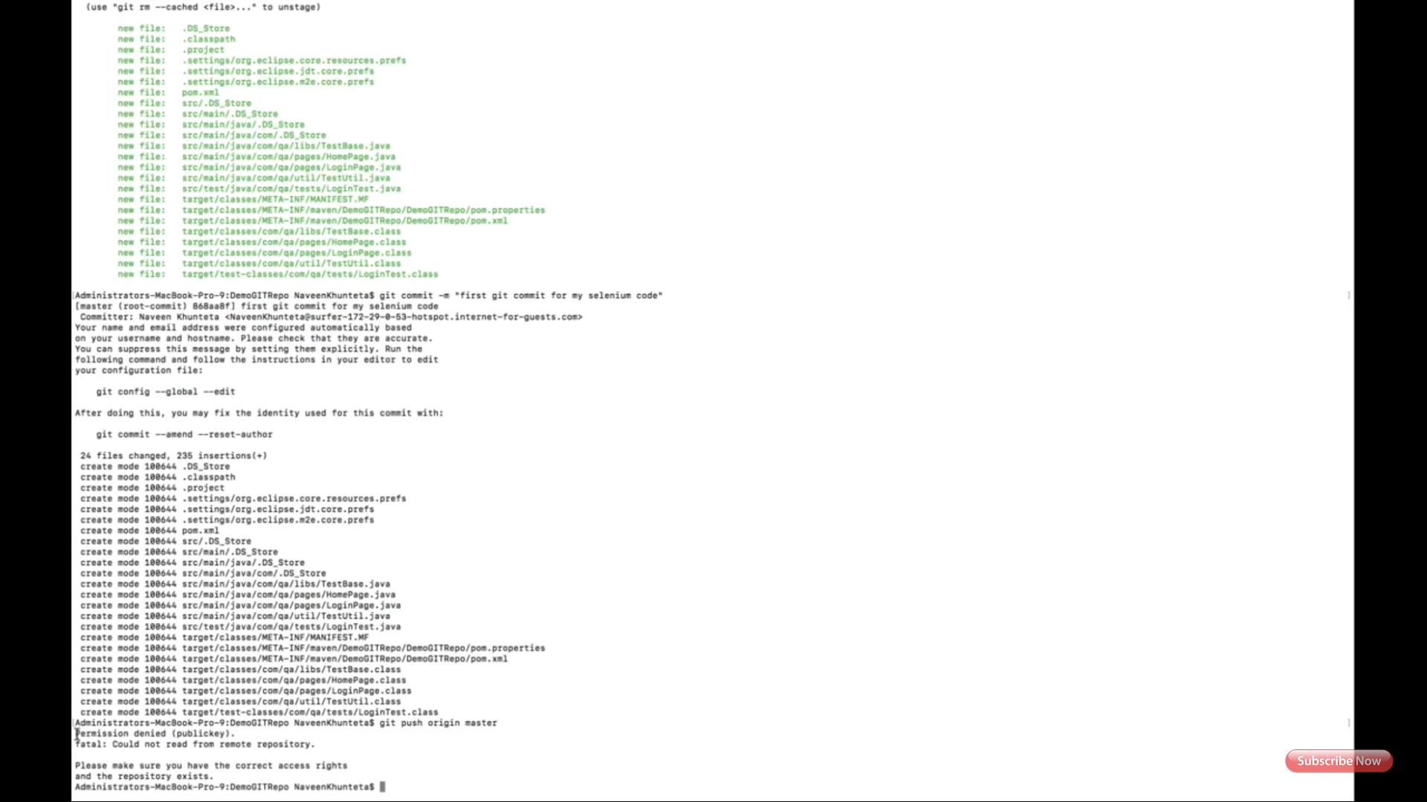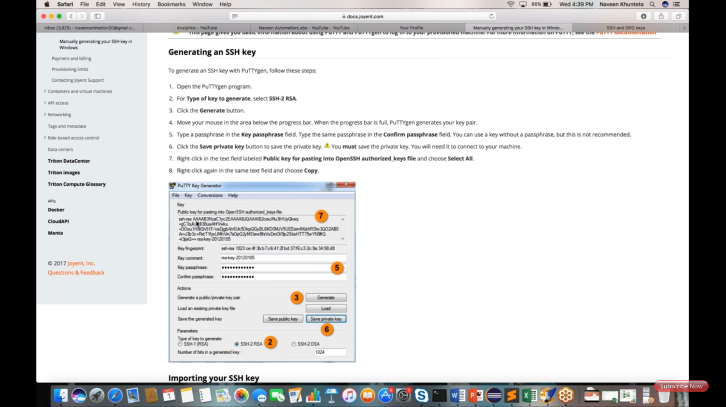

My Creation of SSH KEY: (Command line creation)

Microsoft Windows [Version 10.0.17134.285]

(c) 2018 Microsoft Corporation. All rights reserved.

C:\Users\vishn>cd\

C:\>cd %userprofile%/.ssh

The system cannot find the path specified.

C:\>ssh -keygen -t rsa -C "vishnu.a49@gmail.com"

Bad escape character 'ygen'.

C:\>ssh-keygen -t rsa -C "vishnu.a49@gmail.com"

Generating public/private rsa key pair.

Enter file in which to save the key (C:\Users\vishn/.ssh/id_rsa):

Created directory 'C:\Users\vishn/.ssh'.

Enter passphrase (empty for no passphrase):

Enter same passphrase again:

Your identification has been saved in C:\Users\vishn/.ssh/id_rsa.

Your public key has been saved in C:\Users\vishn/.ssh/id_rsa.pub.

The key fingerprint is:

SHA256:FcEgUgH/rBuym4zW19TpGB64Vmas5GpHfWQ/p9Inqfw vishnu.a49@gmail.com

The key's randomart image is:

+---[RSA 2048]----+

| oo+..oo. |

| o . .. |

| . . |

| o .o |

| +S+ o |

| +.X + o . |

| ..+oX * . = |

| .oo+Bo+.o = . |

| ...**. o+Eo |

+----[SHA256]-----+

Public and private keys available at: C:\Users\vishn\.ssh

C:\>

For putty creation: <https://docs.joyent.com/public-cloud/getting-started/ssh-keys/generating-an-ssh-key-manually/manually-generating-your-ssh-key-in-windows>

Putty: <https://www.chiark.greenend.org.uk/~sgtatham/putty/latest.html>

